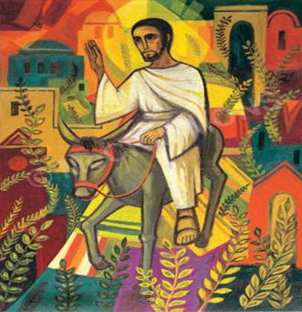

St. Andrew’s United Methodist Church, Charlotte, NC
Online Worship
Palm Sunday
April 5, 2020 10:00 a.m.

GATHERING “Hosanna, Loud Hosanna” Travis

WELCOME

SCRIPTURE READING Matthew 21:1-11

PALM SUNDAY LITANY (see attached)

HYMN UMH # 278 “Hosanna, Loud Hosanna”

CHILDREN’S TIME

ANTHEM “Ain’t No Rock Gonna’ Shout for Me” Larson
PRAYERS OF INTERCESSION

THE LORD’S PRAYER
Our Father, who art in heaven,
hallowed be thy name.
Thy kingdom come,
thy will be done, on earth as it is in heaven.
Give us this day our daily bread.
And forgive us our trespasses,
as we forgive those who trespass against us.
And lead us not into temptation,
but deliver us from evil.
For thine is the kingdom, and the power, and the glory,
forever. Amen.

SCRIPTURE LESSON Philippians 2:1-11

SERMON Having the Mind of Christ

PRAYER OF CONFESSION (see attached)

DRAPING OF THE ALTAR “Come, O Sinner”
HYMN UMH # 289 Ah, Holy Jesus
SENDING FORTH

The words to today’s hymns may be accessed by clicking on the hymn name.
Palm Sunday Litany
(adapted from A COLLECTION OF LITANIES FROM FRAN PRATT)

Hosanna!
Blessed is He who comes in the name of the Lord!

The One we have long awaited, the Messiah, has come.
Riding into Jerusalem, not on a warhorse, but on a young donkey,
The Prince of Peace has come, the one who heals our wounds.
Hosanna!
Blessed is He who comes in the name of the Lord!

Everything that was foretold, Christ has fulfilled.
We offer a sacrifice of praise and thanksgiving.
We set up a banquet, and pour costly perfume at His feet.
Hosanna!
Blessed is he who comes in the name of the Lord.

This is Jesus
Whose name is glorified
This is Jesus
High and lifted up
Hosanna!
Blessed is He who comes in the name of the Lord!

Prayer of Confession

(written by Rev. John Paarlberg, First Church, Albany, New York)

O Lord, who on this day

Entered the rebellious city that later rejected you:

we confess that our wills are as rebellious as Jerusalem's,

our faith is often more show than substance,

our hearts are in need of cleansing.

Have mercy on us, Son of David, Savior of our lives.

Help us to lay at your feet all that we have and all that we are,

trusting you to forgive what is sinful,

to heal what is broken,

to welcome our praises

and to receive us as your own. Amen.

